TRIVENI 1BM19CS411
BDA LAB PRACTICE PROGRAM 1

nsertion

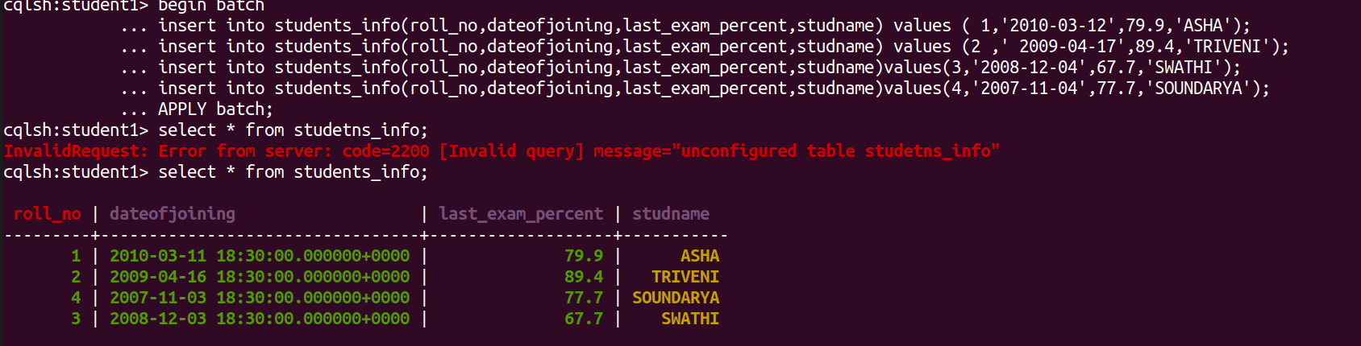
Query 1,2,3,,4

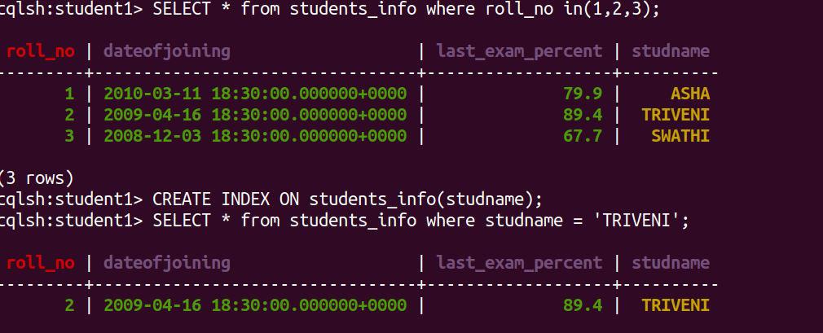

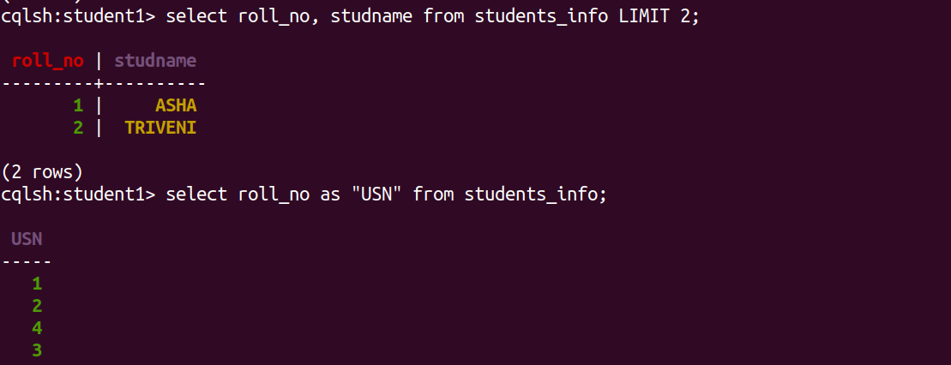
USE OF SET and LIST

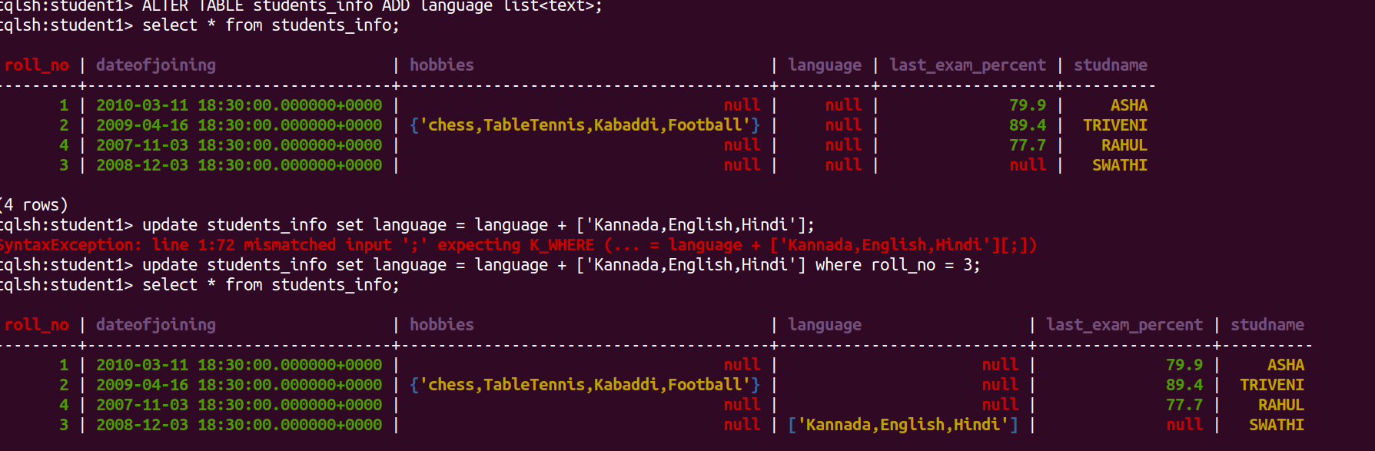

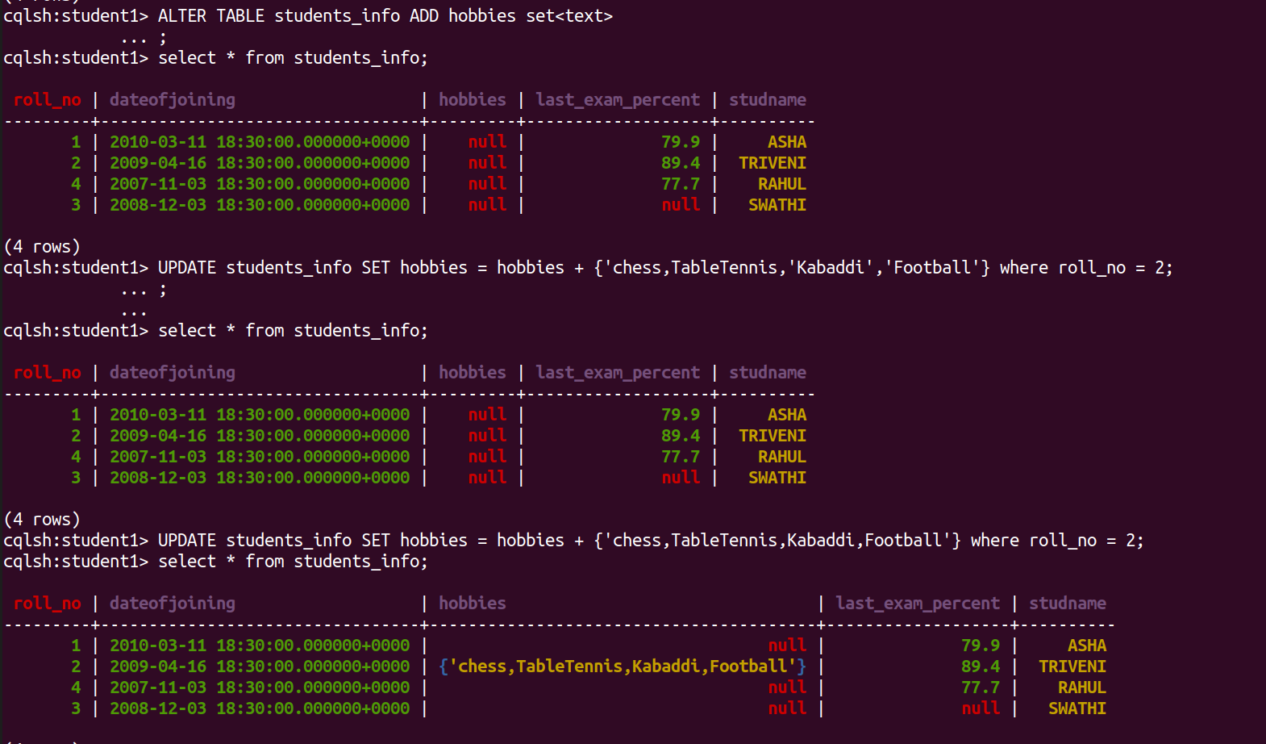
Time To Live
